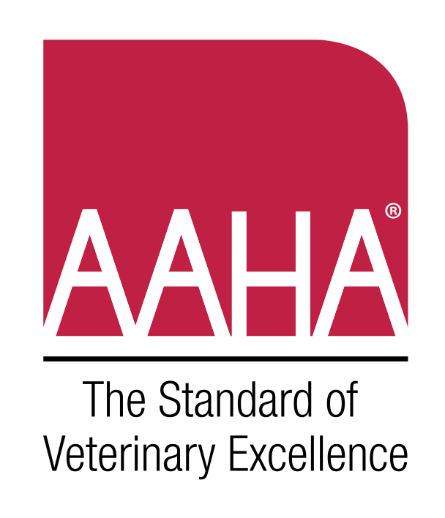


HPAI H5N1

PLANNING FORM

Basic Concept of Operations (ConOps)

Overview

This abbreviated ConOps is a plan outlining basic roles and responsibilities when managing a HPAI H5N1 case in the hospital; a printable/postable key contact list; an equipment checklist; and key elements for case management (protocols/messaging).

Assumptions

This ConOps has been developed for a small animal hospital setting for handling domestic cats infected with H5N1. It is designed to be a template, modified by veterinarians and their staff to meet hospital needs as each facility and team are unique. The plan template may be populated based on a scenario-based planning document.

The chart below is intended to be edited by your team based on your staffing and how you delegate responsibilities.
Add or remove roles as needed. Include as much or little detail as works best to ensure everyone clearly understands who is responsible for each step. We recommend walking through the Scenario document as you update and edit.
***PLEASE DELETE ANY OF THE PRE-FILLED INFORMATION WHICH IS NOT PERTINENT TO YOUR HOSPITAL***
Roles and Responsibilities
Role | Staff Covering (Names) | Primary Responsibilities and Tasks related to H5N1 | Training, Equipment, Protocols needed?
Receptionist |  | - Recognizing suspect case during triage and contacts technician/vet to put on PPE and place patient in isolation area and/or (on phone) how to set up an appointment  - Client communication  - Record transfer to state or local health department  - Record keeping  - Contacting public health/animal health/lab  - Clean/Disinfect | - Training on H5N1 clinical signs & plan to address suspect cases; risk communication,  - PPE use & infection control  - PPE fit-testing  - Equipment: PPE, Key Contact List
Veterinarian |  | - Lead on response, including instituting infection control and staff delegation  - Recognizing suspect case during triage and contacts technician/vet to put on PPE and place patient in isolation area and/or (on phone) how to set up an appointment  - Primary responsibility for reporting by contacting Public Health +/- Animal Health/Lab  - Exam  - Diagnostics  - Record keeping  - Medical plan  - Client communication  - Clean/Disinfect  - Lead After Action Review to identify areas to improve for the next time & celebrate strengths, updating plan | - Training on infection control & PPE use, risk communication  - PPE fit-testing  - Equipment: Disinfectants, diagnostic sample collection/forms, PPE, Key Contact List
Veterinary Technician |  | - Recognizing suspect case during triage and contacts technician/vet to put on PPE and place patient in isolation area and/or (on phone) how to set up an appointment  - Setting up infection control  - Patient care  - Client communication  - Record keeping  - Diagnostics & sending samples to laboratory  - Contacts public health/animal health/lab as directed by veterinarian | - Training on Infection Control & PPE use, Risk Communication  - PPE fit-testing  - Equipment: Disinfectants, diagnostic sample collection/forms, PPE, Key Contact List
Animal Care/ Kennel Staff |  | - Clean/Disinfect  - Patient care | - Training on Infection Control & PPE use  - PPE fit-testing  - Equipment: Disinfectants, diagnostic sample collection/forms, PPE
Office Manager |  | - Client communication  - Record transfer to state or local health agencies

Key Contacts

In the event of a suspected case of HPAI H5N1, please contact your public health office and/or your animal health office.

HPAI H5N1 is reportable. Here are links to help you:

State public health veterinarians
State animal health officials
Laboratories within the National Animal Health Laboratory Network (NAHLN)

Contact | Phone number | Name of contact
Public Health Office/Veterinarian
Animal Health Office
Diagnostic Laboratory (for HPAI H5N1 testing)

HPAI H5N1 Equipment and Supplies Checklist
INFECTION CONTROL |  |  | TESTING
PPE |  |  | Supplies for swabs (nasal, oropharyngeal, fecal), blood, and urine samples*
 | NIOSH approved respirators |  |  | Purple top tube
 | Goggles |  |  | Polyester tipped swabs
 | Face Shields |  |  | Blood/urine collection (syringes, needles, ultrasound/catheter)
 | Coveralls |  |  | Sterile containers/red top tube
 | Apron |  |  | Viral transport media, saline
 | Face shield |  |  | Sturdy waterproof containers; insulated
 | Boot covers/boots |  |  | Ice packs for shipping
 | Head/hair cover
 | Disposable gloves and work gloves |  | HANDOUTS/FORMS
Disinfectants (Check what you have/will use, you don’t need them all) |  |  |  | Phone/appointment triage questions
 | Quaternary Ammonium |  |  | Call list for Public/Animal Health reporting and laboratories for submitting samples
 | Phenolic
 | Glutaraldehyde |  |  | Client communication
 | Citric acid, silver ion |  |  | Staff safety handout
 | Sodium hypochlorite (bleach)
 | Dodecylbenzenesulfonic acid
 | Hydrogen peroxide; Peroxyacetic acid
 | Ethanol

Protocols/Messaging

Please fill in the list as needed to reflect what’s appropriate for your team. In addition to outlining roles and responsibilities, it’s helpful to have protocols and pre-drafted risk communication messages readily accessible for quick reference in the event of a HPAI H5N1 case. Please use these reference materials to help inform your protocol, if helpful.

Protocols | Resources
HPAI H5N1 Infection Control Protocols | CDC–Cats  CDC Recommendations for People Working with Animals, Including PPE and Engineering/Administrative Controls  AAHA Trends - Risky Business  AAHA 2018 Biosecurity Protocols

HPAI H5N1 Protocols for Reporting Case
HPAI H5N1 Protocols for Exposed Staff | CDC–Information for People Exposed to H5N1

HPAI H5N1 Triage/Reception Protocols
HPAI H5N1 Treatment Protocols | CDPH–Treatment of Cats

HPAI H5N1 Testing/Sample Collection Protocols

HPAI H5N1 Post-mortem handling and disposal protocols
HPAI H5N1 Risk Communication | Draft Messages for exposed staff  Draft Messages for exposed or concerned clients

